Next Day Funding

To create the systemic opportunity for a merchant to receive fund deposits next day, the application should be submitted or the merchant record updated to transmit settled batches using Tape ID 3. The terminal will also have to be setup to settle in a timely manner to ensure that specified cut cycles are met. Instructions for setting up merchants for Tape ID 3 or updating an existing merchant are detailed below. Also included in this document are terminal download instructions required for Next Day Funding.

Note: Tape ID three and settlement only ensures that the funds are available to the merchant’s bank. It is up to the bank to post these funds to the merchant’s account in a timely manner.

MSP Billing will occur at the Merchant Level if the merchant is setup for Tape ID 3. If terminal prompts are not set properly or the merchant’s bank does not release funds in a timely manner, we can not ensure that the merchant will receive Next Day Funding. The MSP is responsible for validating this information.

Updates to Existing Accounts

Tape ID can be updated upon request through MSP Support by emailing mspserv@novainfo.com or calling 888-479-9138. If a monthly fee is being added to the merchant, a signed MSP Rate Change Update form will be required.

Setup through Merchant Application

In the Bank Account Information section on the Merchant Application, the user should indicate “3” in the Tape ID field. Terminal download instructions below should be followed.

Setup through MSP Fast

In the Account Manager on the Merchant Application screen, the user should indicate 3-Central Bank in the Tape ID dropdown. Terminal download instructions below should be followed.

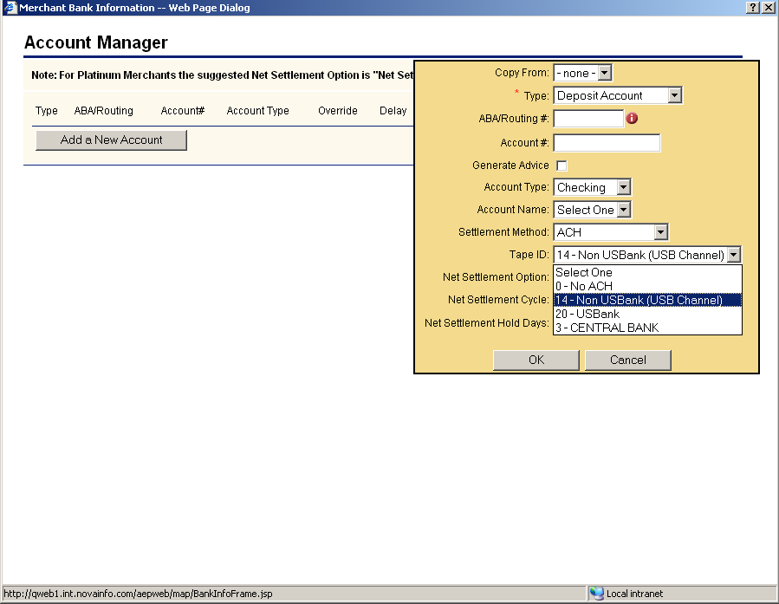

Terminal Download Instructions

The terminal settlement time for next day funding should be established at 9:30PM EST. Because the default auto close time is 11:30 PM EST, the MSP may have to call or email MSP Support to update auto close time setup in the file.

