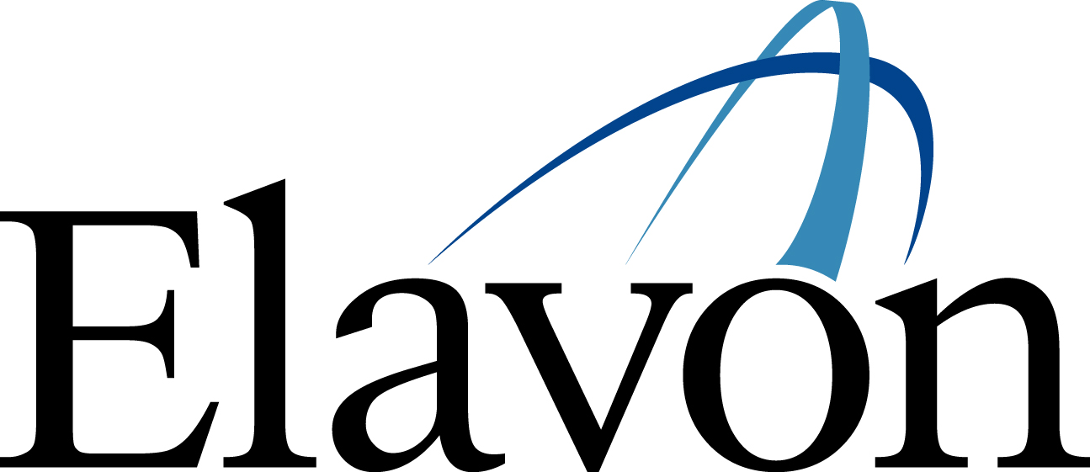

ELAVON Download Phone Numbers

Nurit – 800-211-7878 (WorldCom)
800-397-0638 (AT&T)

Verifone – 800-472-5850
888-545-2231 (AT&T)
800-291-9942

Hypercom T7 Series –
888-820-6596 (WorldCom)
800-711-5479 (AT&T)

Hypercom T4100 –
888-545-2230

Dassault – 888-545-2231 (WorldCom)

Ingenico (CANADA ONLY) –
888-545-2231
800-472-5850

ELAVON Terminal Authorization Phone Numbers

Primary – 800-741-3731 (WorldCom)

Secondary – 800-972-4608 (AT&T)

