Demo Documentation


Contents

INTRODUCTION TO ACS 3
WHAT IS ACS? 3
System Requirements 3
Stand-alone Installation 3
Installing ACS for LAN Access 3
Definition of Terms 3
Special Note to LAN Administrators 3
Configuration: 3
Starting ACS 3
Logon: 3
Setting System Parameters: 3
Change Remote 3
FTP Configuration 3
Change User Name 3
Change Password 3
Admin 3
Merchant Profile 3
Chargeback/Retrievals 3
Chargeback 3
Retrieval 3
Reports 3
Authorization 3
Settlement 3
Statement 3
Custom Reports 3
Additional Features 3
Exception Reports 3
Sort Command 3
Export Function 3
Interchange Summary Report 3
Tools 3
Backup 3
Communication 3
Dial-up 3
Internet 3
Appendices 3
Appendix- A Authorization File Layout 3
Appendix – B Settlement File Layout 3
Batch Header Record 3
Settled Items Record 3
Appendix – C Merchant Profile File Layout 3
Appendix – D Chargeback File Layout 3
Appendix – E Retrieval File Layout 3
Exception Parameters 3
Appendix – F Data Definitions 3
Table 40-A Transaction Types 3
Table 40-B Card Types 3
Table 40-C Method and Indicator Values 3
Table 40-D Switch-Ids 3
Table 40-E Reply Codes 3

INTRODUCTION TO ACS

WHAT IS ACS?

Elavon’s Automated Customer Service System, “ACS” is a reporting and account reconciliation tool. ACS provides a complete account/portfolio management tool for the smaller merchant up to the large chain or bank entity. View detailed reports of transaction activity, statement detail, card type history, qualification detail and much more. A Windows based software program, you will find ACS a user friendly system. Easy to understand prompts and menus guide you through you merchant program.

ACS Features:

- Complete database of merchant-specific data
- Built-in back-up and file retrieval system
- Chargeback and Retrieval notification and status information
- New Software updates
- System Reports:
- Daily Transaction Details and Summaries
- Daily Exception Reports (11 different reports available)
- Card Type Report
- Review Activity- Query by card type
- Statement Review
- Interchange Summary
- Custom Authorization and Settlement Report option
- Admin Functions:
- System Setup
- Back-Up Option
- Communication Option

Demo Report Dates:
Viewing Reports:

In order to see the demo data, please note the dates of the files to view.

- Authorization & Settlement report dates: November 10, 2002
- Interchange Report: October 18.2002
- Chargeback/Retrieval files are viewable by selecting the chargebacl/retrieval module and select the dates.
- Merchant Profile test Merchant account numbers:

- 385111111111111
- 385111111111112

- Exception Reports: Click on the Exception tab under reports. You will find the sample “Exception reports by doing the following:
- In the “Look In” parameter click on the “C” drive.
- Click on the folder named “ACS”
- Click on the folder named “EXP”
- Under the “Files of type” click on “all files”

The exception reports will be displayed. Click on any report to see the report data.

System Requirements

Computer | Pentium 166 MHz (Recommended)
RAM | 64 Meg (Recommended)
Modem | 33.6 or Higher
Free Disk Space | 100 Megs. Minimum
Operating System | Windows 98/NT 4.0/2000/XP
Internet Connection | FTP support
Dial-Up Connection | FTP support
FTP Capability | (Port 22) Enabled

Stand-alone Installation

This section deals with Installing ACS as a stand-alone application. For Network Installation see the section titled Network Installation.

Step 1. Insert CD labeled ACS into the CD drive. If the Auto Run feature is enabled on your system, the auto install program will run.

Step 2. If the Auto Run option is not enabled on your system, then from the Windows Start Menu, select Run.

Step 3. Type “ x:\setup” (where x = drive letter where the program will be installed on) then press Enter. The Installation Wizard will begin the set-up program routine.

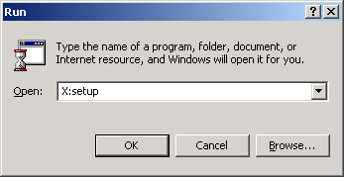

Step 4. On the welcome screen, press Next to continue the installation process.

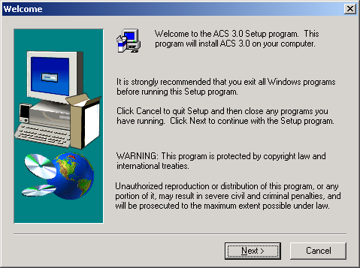

Step 5. Select the Installation Directory. Press Browse to install to a Drive other than the default Drive listed. Then press Next to continue.

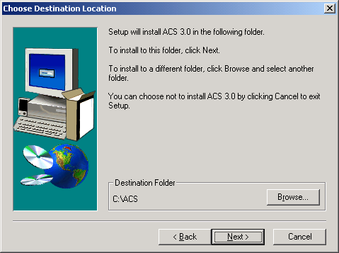

Step 6. ACS setup will display the program Folder selected for installation. Click next

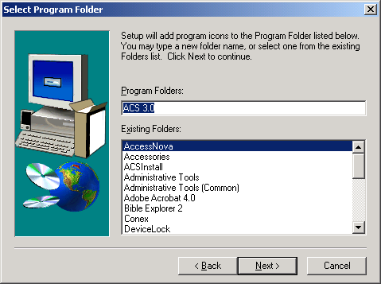

Step 7. The Install program will begin copying the files onto your computer. Click Next

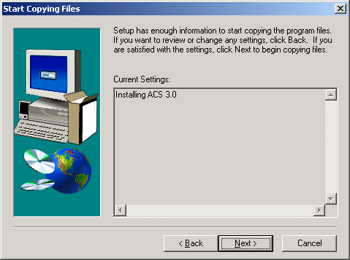

Step8. After the files has been Installed, click Finished.

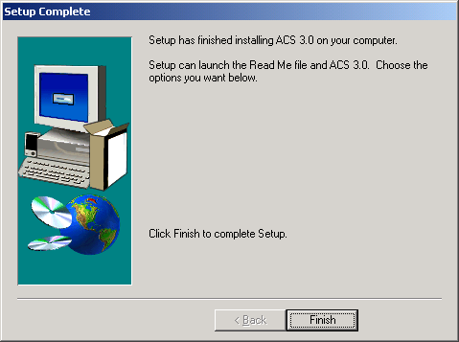

You will need to create a shortcut for the demo program. To create a shortcut, please see below.

- Open “My Computer”
- Double click on the “C” drive
- Click on the “ACS” folder
- Highlight the ACS.exe icon
- Click on the File icon at the top and choose create shortcut
- Drag shortcut onto your desktop.

Installing ACS for LAN Access

ACS can be installed on a Local Area Network (LAN) by following these guidelines.

Definition of Terms
Before you begin the installation, it is important that you understand the terms being used in this guide:

Control Station -The station on which the modem is installed or has Internet connectivity. All management functions will be performed from this station, including File Transfer, and Configuration changes. All other ACS functions can also be performed here as desired, but those listed above MUST be done here. There can be only ONE Control station per installed site.

Work Station -This station is used for generation of reports, reviewing data researching items and general daily work. There can be as many workstations set up as desired to meet the requirements of the site.

LAN - Local area Network, currently the ACS system has been tested on the NOVELL and NT LAN environments.

Special Note to LAN Administrators
NOVELL Network Administrators: The files in the ACS/Data directory must be set to allow multiple access. This can be accomplished by running the FLAG program and setting the attribute on these files to ”shared.”

NT Network Administrators: The ACS directory and all of its sub-directories must be set up to allow read / write / update capabilities to all files contained in them for all users accessing the ACS system. There are NT administrator programs for accomplishing this function.

Elavon cannot provide LAN-level support but will readily respond to your questions about the ACS software.

Step 1. Insert CD labeled ACS into the CD drive. If the Auto Run feature is enabled on your system, the auto install program will run.

Step 2. If the Auto Run option is not enabled on your system, then from the Windows Start Menu, select Run.

Step 3. Type “ x:\setup” (where x = drive letter where the program will be installed on) then press Enter. The Installation Wizard will begin the set-up program routine.

Follow Steps as outlined for “Stand-alone” Installations. An icon should appear on your desktop.

Configuration:

Starting ACS

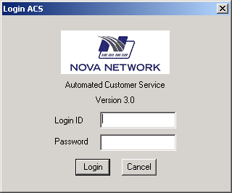
Logon:

Step 1. Key in your Logon ID as provided by Elavon and press [Enter] or click the mouse in the password box.

Step2. Type in your password as provided by Elavon. If using your keyboard, press [Enter].

Step3. Click on the Login button.

Note: Passwords in ACS are case sensitive.

Setting System Parameters:

Step 1. Click on the Tools icon.

Step 2. Click on the System Setup icon
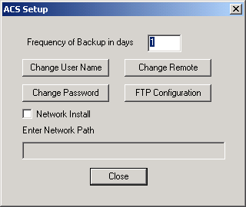
Workstation Note: If this is a LAN-level install, click on the “check” box that say’s “Network Install” and enter the path to the Control Station where ACS has been Installed into the text field.

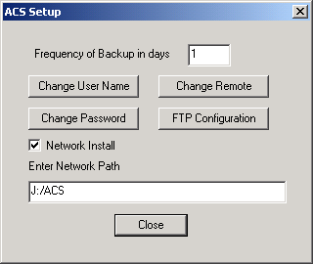
Example:

Change Remote

Step 1. To enter your Remote ID as supplied by Nova, click on the Change Remote button and enter the Remote Id as supplied by Nova (001348) for demo application and click ok.
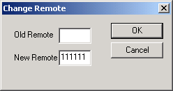

FTP Configuration
Skip this section if you are using the demo guide.
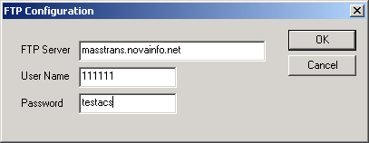
Step 1. To configure you FTP module, click on FTP Configuration and enter the information as supplied by Nova and click ok.

Change User Name

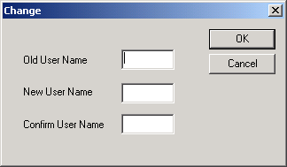
Step 1. Click on the Change User Name button and enter your new User Name and click ok.

Change Password

Step 1. Click on the Password button and enter you new Password and click ok.

Admin

Merchant Profile

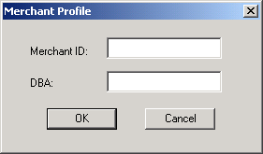
Step 1. Click on Merchant Profile. Enter the Merchant number or the DBA name and click ok to display detailed information about the merchant’s locations within your account/portfolio. Ensure that information is accurate or that a requested information update has been implemented

Demo mid: 385111111111111
385111111111112

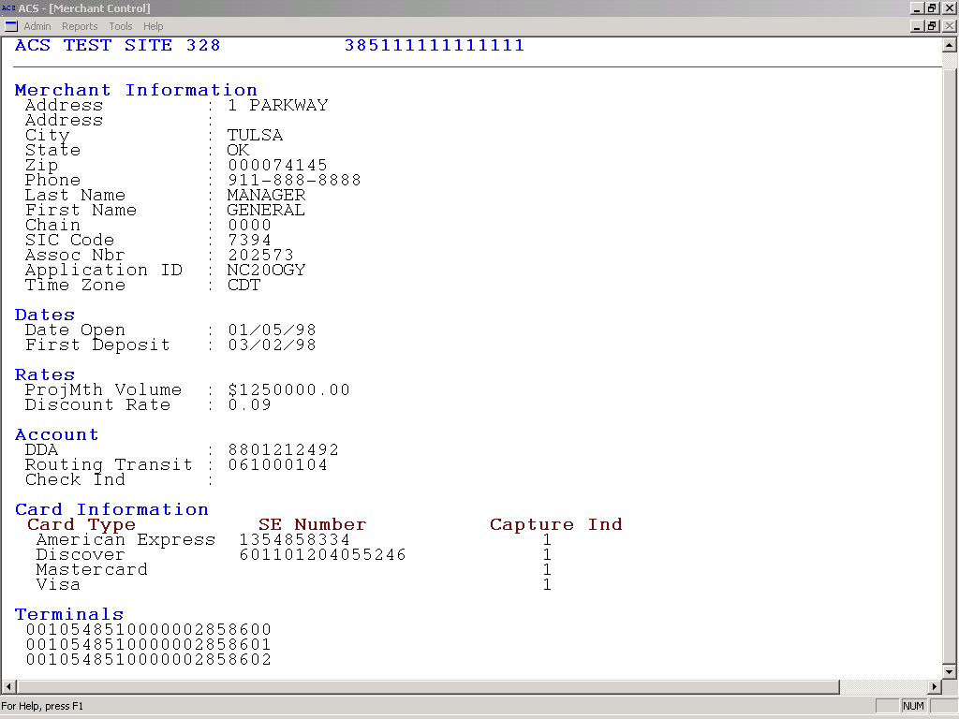

111111111
111111111

Chargeback/Retrievals
Demo purposes, click on the status button to choose dates.

With ACS, you have access to chargeback and retrieval data for your merchants. Receiving this information on a daily basis will help you to track responses to retrieval requests and the status of chargeback situations.

You can receive retrieval requests via ACS rather than by mail, which will provide you with advance on-line notification of all requests. This feature allows you to:

- Look up your "new today" retrievals on a daily basis.
- Keep a 21-day working file of whether or not responses to retrieval requests have been submitted.
- To access chargeback and retrieval data.

Chargeback

Step 1. From the ACR drop-down menu, click on Chargeback. The following Options screen will appear:

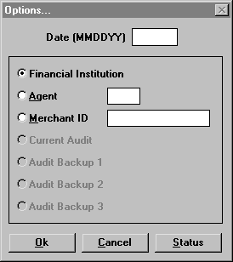

Step 2. Enter the Date of the chargeback record(s) you wish to view. If you do not know the date, click on Status to view a list of all chargeback files received and stored in ACS. The following screen will appear:

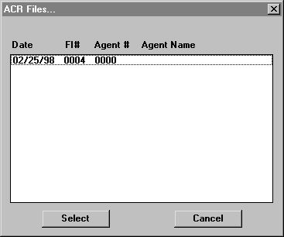

Step 3. Click on the file you wish to view, click on Select, and the file date will be transferred to the Options screen.

If you select Financial Institution, you will receive all existing chargeback files for that date. If you wish to narrow your Chargeback report, you may access records by a particular Agent or Merchant ID number.

Step 4. Click on OK to generate the report:

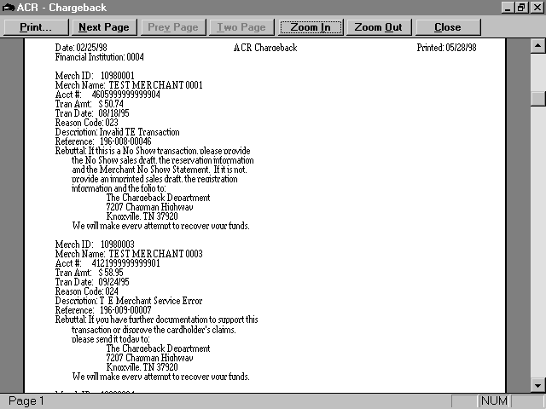

All chargeback notices on file for the selected date will appear on the screen.

You may use the tool bar across the top of the screen to view the Next Page, Previous Page, Zoom In to make the report larger, or Zoom Out to make the report smaller. You may print the report file by selecting Print. Click on Close to exit the report.

Chargeback files remain on line for 21 days and are automatically deleted after that time.

Retrieval

Step 1. From the ACR drop-down menu, click on Retrieval. The following Options screen will appear:

Step 2. Enter the Date of the retrieval record(s) you wish to view. If you do not know the date, click on Status to view a list of all retrieval files received and stored in ACS. The following screen will appear:
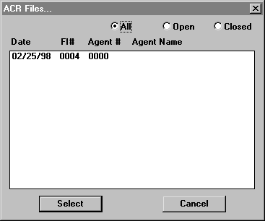

Step 3. Select All to view all retrieval files, Open to view only open files, or Closed to view only closed files. Click on the file you wish to view, click on Select, and the file date will be transferred to the Options screen.

If you select Financial Institution from the Options screen, you will receive all existing retrieval files for that date. If you wish to narrow your retrieval report, you may access records by a particular Agent or Merchant ID number.

Step 4. Click on OK to generate the report:

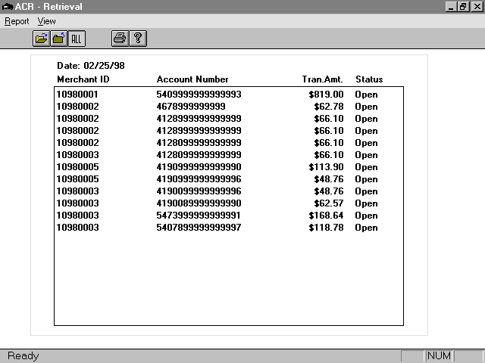

If you click on an individual record, the following screen will appear:

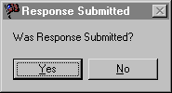

If you answer yes, the file will be closed in ACS and will appear in red type. If you answer No, the file will remain open and will appear in black type.

To view the report as it will look when it is printed, click on Report and on Print Preview.
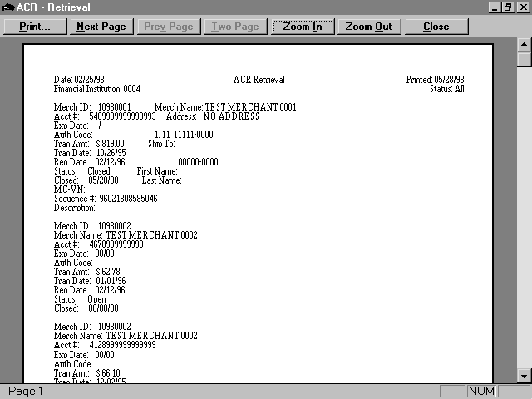

You may use the tool bar across the top of the screen to view the Next Page, Previous Page, Zoom In to make the report larger, or Zoom Out to make the report smaller. You may print the report file by selecting Print. Click on Close to exit the report.

Reports

Authorization
Demo mids: 385111111111111
385111111111112

Step 1. From the Main Menu, click on the Reports tab.

Step 2. Click on the Authorization tab.
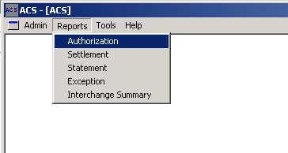

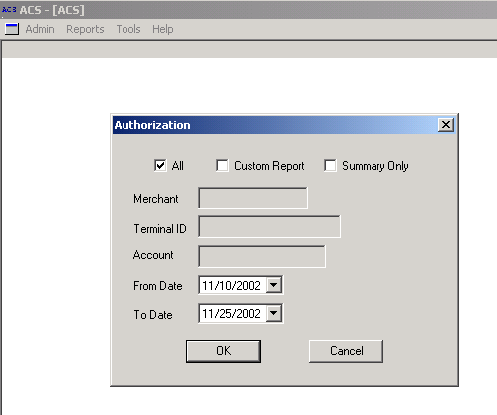

Step 3. From the Authorization window select:
- All: click here to view all Authorization transactions from every location within your portfolio.
- Summary: Clicking on the Summary check box will pull up Summary information (only).
- Merchant: Enter a specific Merchant number to view all Authorization transactions for that Merchant ID.
- Terminal ID: Enter a specific Merchant and Terminal number to view all Authorization transactions under that Terminal ID.
- Account: Enter an Account number to view all Authorization transactions processed under that Account.
- From Date: Click and choose the dates for your report by clicking on the Down arrow in the From Date and To Date section.

A full sample report is shown below. ACS automatically provides you with a summary view box of all authorizations for your account/portfolio.

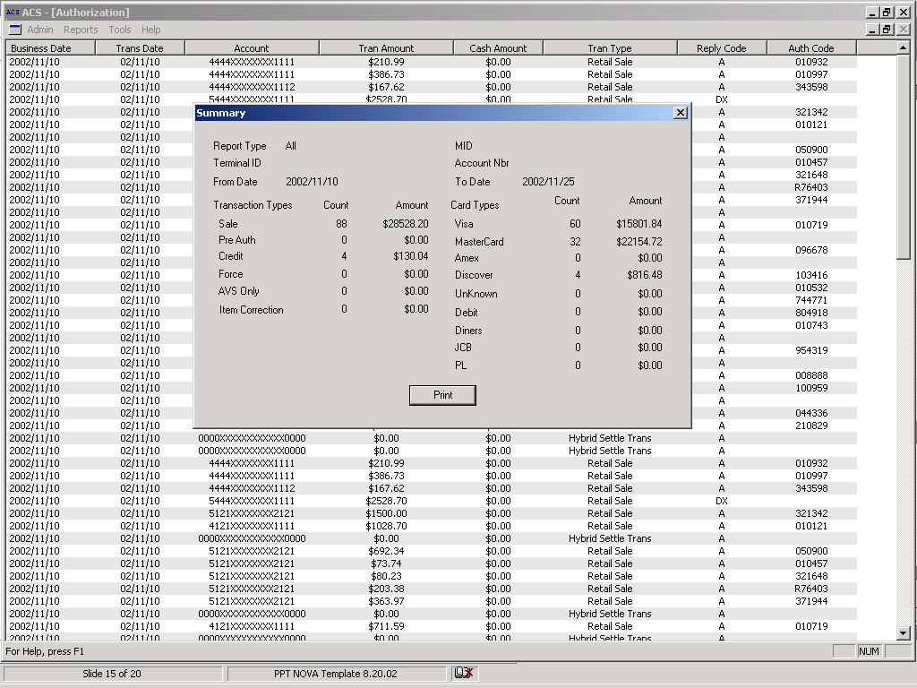

As an added level of security, transaction detail information is protected by a separate password. Type in the password as provided to you by Nova.

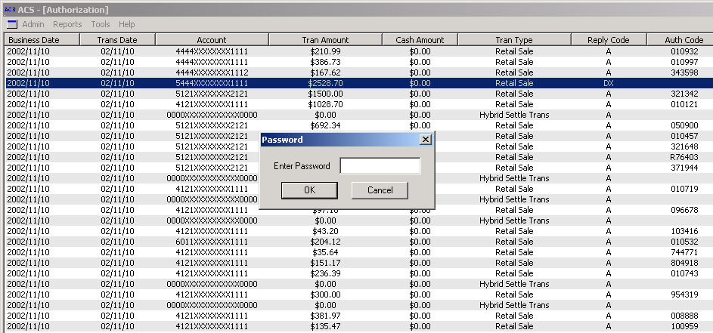

Once the password is entered, detail about the specific transaction you selected will appear in a separate box. See below.

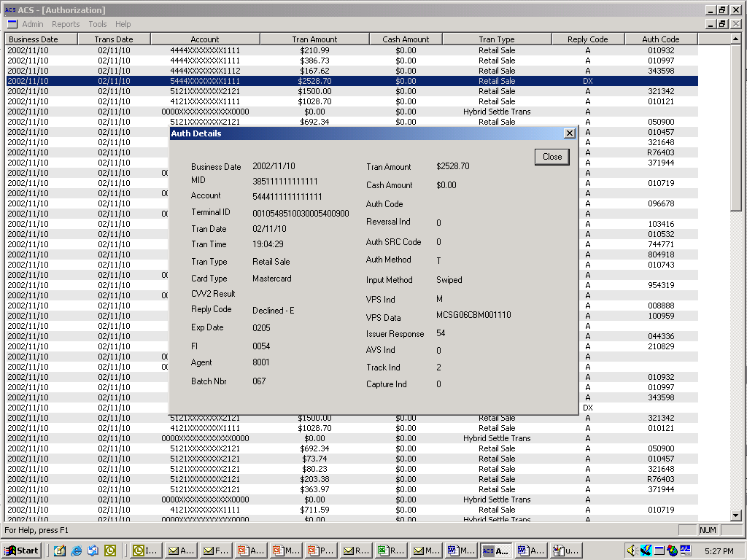
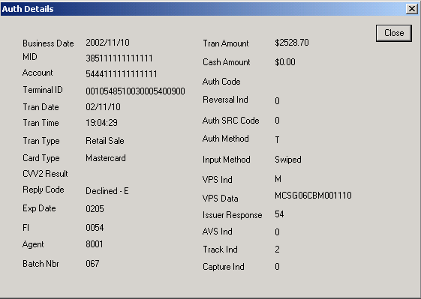

Settlement
Demo mids: 38511111111111
385111111111112
Step 1. From the Main Menu, click on the Reports tab.

Step 2. Click on the Settlement tab.
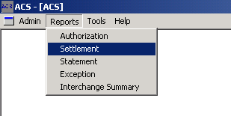

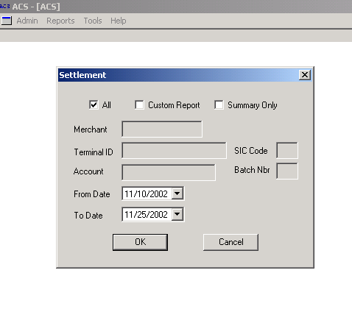

Step 3. From the Settlement window select:
- All: click here to view all settlement batches from every location within your portfolio.
- Summary: Clicking on the Summary check box will pull up Summary information (only).
- Merchant: Enter a specific Merchant number to view all settlement batch information for that Merchant ID.
- Terminal ID: Enter a specific Merchant and Terminal number to view all settlement batch information for that Terminal ID.
- Account: Enter a Merchant/Terminal/ Account number to view all settlement activity processed under that Account.
- From Date: Click and choose the dates for your report by clicking on the Down arrow in the From Date and To Date section.

A full sample report is shown below. ACS automatically provides you with a summary view box of all settlement activity for your account/portfolio.

Sample report:

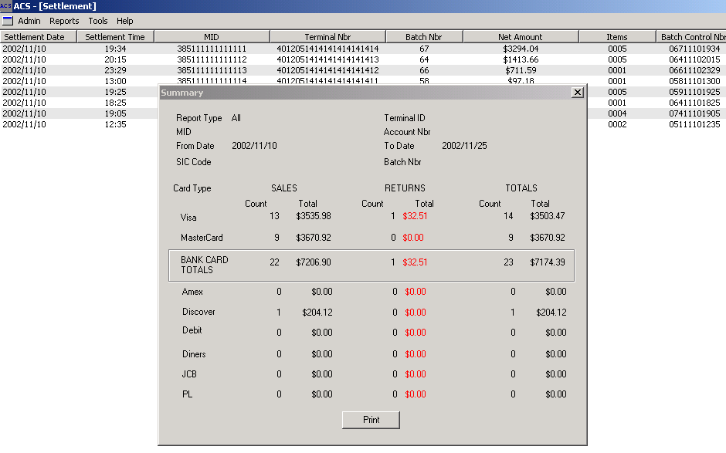

Step 4. Easy to read summary detail shows totals by card type. To view settlement detail on a specific batch, simply double click on the batch record you would like to view.

Step 5. Again, all detail information is protected by a separate password, ensuring that full card # information is only viewed by those with access rights. Type in the password as provided to you by Nova.

Sample report.

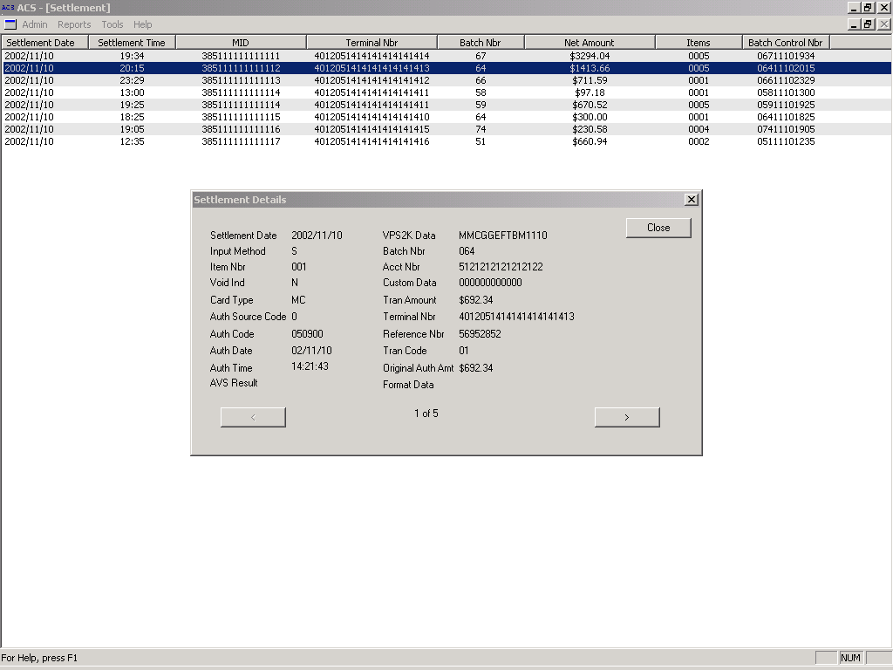

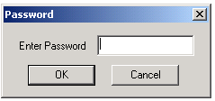

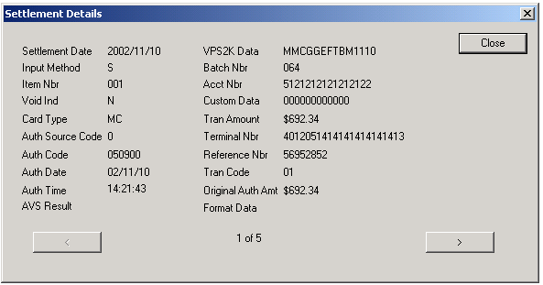

Statement

ACS enables you to look at detailed monthly statements by Merchant ID. Statements provide an at a glance summary section followed by supporting deposit and fee detail.

Step 1 From the Main Menu, click on the Reports tab.
Step 2. Click on the Statement tab and click Open as shown below.

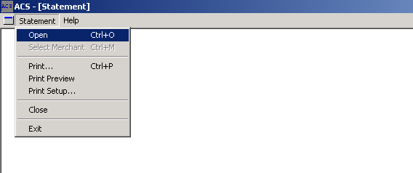

Step 3. Select the Remote ID and the Month of the statement that you want to view. A detailed statement will appear listed by Merchant Id.

Step 4. You can choose individual Merchant statements by scrolling on the Merchant ID’s and clicking on it.

See sample Statement file.

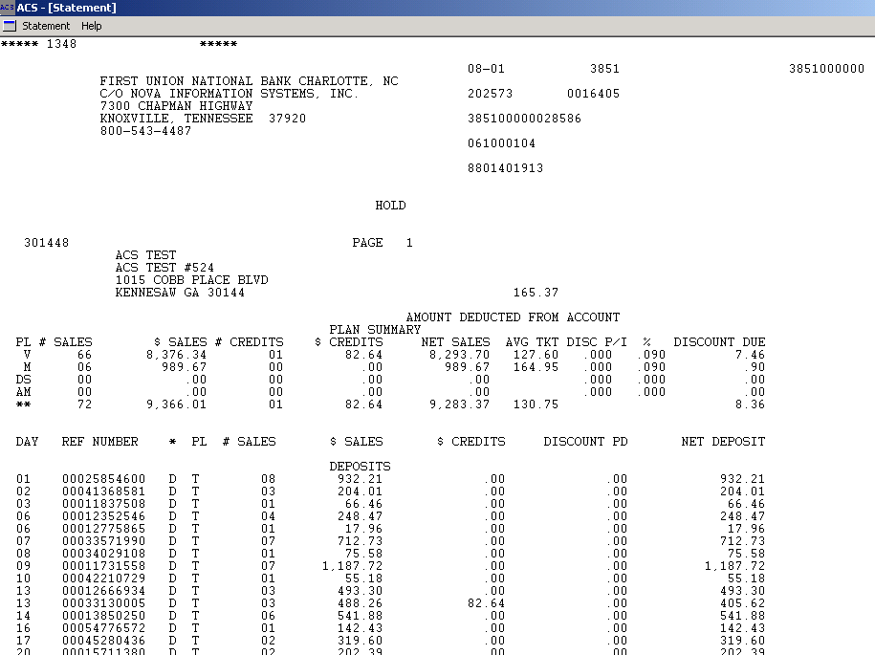
ACS NATIONAL BANK
SAMPLE STATEMENT
385111111111111
111111

1 ACS Blvd.

Custom Reports

ACS offers the ability to create custom reports for both Authorization and Settlement information.

Step 1. From the main Report menu, click on either Authorization or Settlement tab for the report of your choice. For this example we will use the Authorization module.
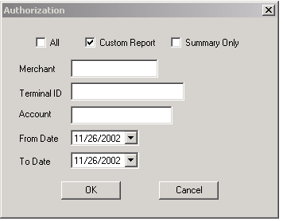

Step 2. Click the Custom check box.
You can customize your report by
Merchant/Terminal/Account or by
All.

Step 3. Simply click on the information you would like to include in a report
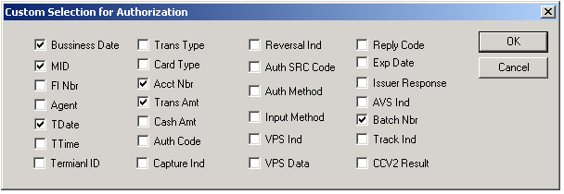

ACS will store your custom selections for use the next time you request a custom report

See Sample Report.

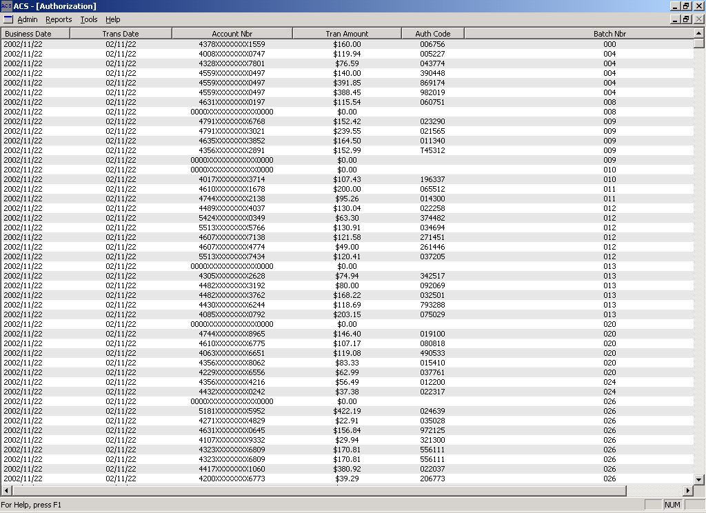

Additional Features

Exception Reports
Exception reports are available to help you identify “out of the ordinary” occurrences that may need attention.

Note: Exception Reports is an optional feature of ACS. These reports are dynamically built according to each Merchants specifications by Nova.

- Exception Reports include the following.
- Chargeback volume to Gross sales
- Chargeback by Reason Code
- % Return Volume to Daily Gross Sales
- Processed volume to Projected Volume
- Average Ticket to Approved Average Ticket
- Largest ticket per Batch to Average Ticket
- Excessive Keyed Transactions
- # Credit Transactions to set Maximum
- Merchants open 3 months with no activity
- Location of first deposit in over 6 months
- # Transactions over Daily Maximum

Note: All reports are parameter driven. Parameters are set by end user. See sample report below.

See Sample Processed Volume to Projected Volume Report below.

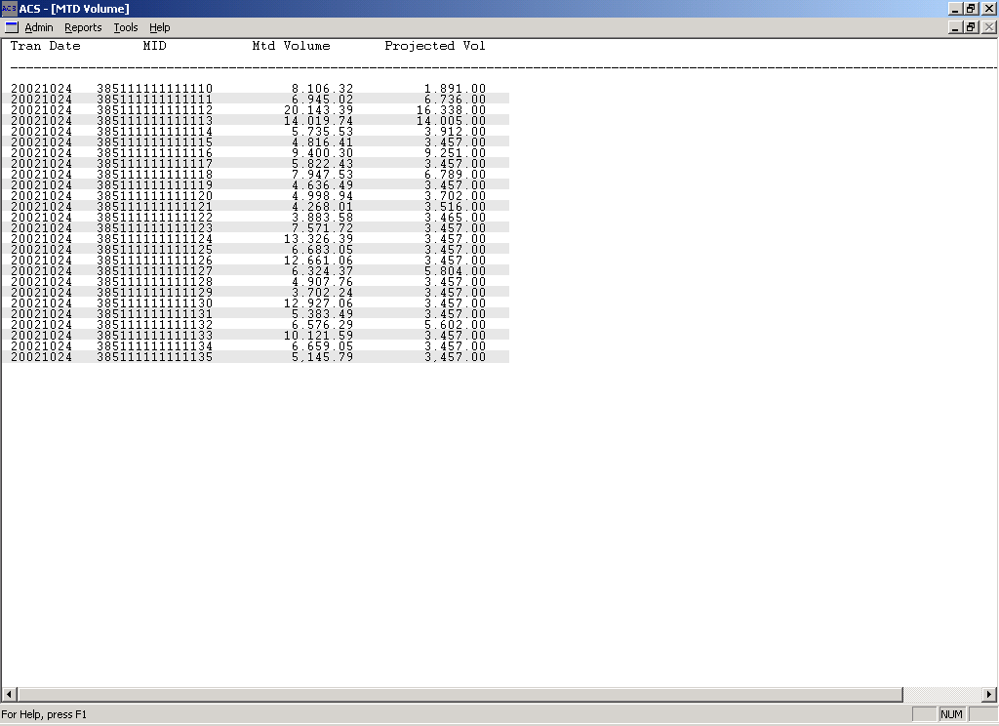

Sort Command

ACS Reports can be sorted by any of the column headers
For example, to sort by date simply click on “Business Date.

Export Function

Files can easily be exported into external applications. To export Authorization or Settlement files, after you have made your selections from the Authorization or Settlement module follow the procedures listed below.

Step 1. While the file is displayed, click on the Admin icon and choose export.

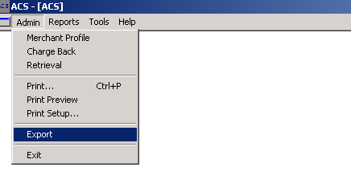

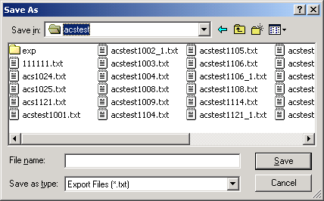
Step 2. Name the file and save it into the folder of your choosing. ACS will automatically save the exported file as a Text file.

Step 3. Open file using the external application of choice ie.. (Excel) as a delimited file following the application wizard’s instruction.

Note: Please ask your trainer to go over this function with you during your training session, or call PC Support.

Interchange Summary Report

- This Report supplies Interchange codes listed by card type
- Allows you to proactively monitor you merchant locations for proper compliance
- Available National/Regional/Community Bank accounts.
- Report available upon request.

Tools

Backup

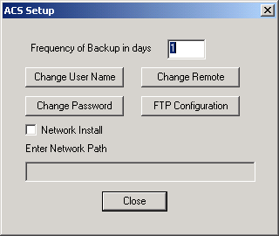
Step 1. ACS automatically provides you the tools to archive your data files. The System will automatically prompt you for archival support based on the frequency of days that was entered at setup. Type in the number of days that you will allow between backups. For example: Based on the input below, the ACS system will prompt me to backup my files everyday.

Step 2. Upon exiting the ACS system based on the input above, the system will display the following prompt. If you click “yes”, the system will automatically backup your data files and place a zipped file into the “ACS” directory. At this time you can rename the file as deemed necessary. If you click “no” the system will bypass the archival process and prompt you again the next time you exit the system.

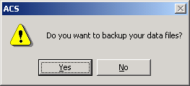

Communication

ACS provides two FTP methods of transferering your files from the ACS Server to your Desktop. Dial-up, or Internet.

Dial-up

For Dial-up access into the ACS file server you must have the following installed on your PC. ACS supports FTP for Dial-up and SFTP for Internet access. The following Protocols must be Installed on your PC.

- Dial-Up Networking
- PPP
- TCPIP

Contact you Help Desk support to ensure that all protocols are installed on you PC. The Nova representative will walk you through the correct settings to ensure that you have everything set correctly.

Internet

ACS establishes a secure connection between the ACS server and your computer. The Nova representative will walk you through connecting via the Internet.

Appendices

Appendix- A Authorization File Layout

Variable Name | Data Type | Size | Value | Table Name
Record Type | Char | 2 | AU
Business Date | Date | 8
Terminal Number | Char | 22
Merchant Number | Char | 16
FI Number | Int | 4
Agent | Int | 4
Trans Date | Date | 6
Trans Time | Char | 6
Trans Type | Char | 2
Card Type | Char | 2
Account Number | Char | 24
Trans Amount | Float | 12
Cash Amount | Float | 12
Auth Code | Char | 6
Reversal Ind. | Char | 1
Auth Source Code | Char | 1
Auth Method | Char | 1
Input Method | Char | 1
VPS Ind. | Char | 1
VPS Data | Char | 20
Reply Code | Char | 2
Exp. Date | Char | 4
Issuer Response | Char | 2
AVS Ind | Char | 1
Track Ind | Char | 1
CVV2 Result | Char | 1
Capture Ind | Char | 1
Batch Nbr | Char | 3
Format Data | Char | 132

Appendix – B Settlement File Layout

Batch Header Record

Variable Name | Data Type | Size | Value
Record Type | Char | 2 | BH
Settlement Date | Date | 8
Terminal Number | Char | 22
Batch Number | Int | 3
FI# | Int | 4
Agent# | Int | 4
Merchant Number | Char | 16
Batch Control Number | Char | 12
Settlement time | Date | 6
Settlement Type | Char | 1
Auto Close Ind | Char | 1
Application Id | Char | 8
Net Amount | Float | 12.2
Items | Int | 4
Chain | Int | 4
Sic Cat | Int | 4
Batch Status | Char | 1

Settled Items Record

SI Record Layout

Variable | Data Type | Size | Value | Table Name
Record Type | Char | 2 | SI
Settlement Date | Date | 8
Terminal Number | Char | 22
Batch Number | Int | 3
Item Number | Int | 4
Tran Code | Char | 2
Account Number | Char | 24
Card Type | Char | 2
Trans Amount | Float | 8.2
Auth Code | Char | 6
Auth Date | Char | 6
Auth Time | Char | 6
Custom Data | Char | 12
Input Method | Char | 1
Auth Source Code | Char | 1
Void Ind | Char | 1
VPS2K Data | Char | 20
AVS Result | Char | 1
Orig Auth Amount | Float | 8.2
Reference Number | Int | 12

Appendix – C Merchant Profile File Layout

Variable Name | Data Type | Size | Value
Record Type | Char | 2 | 10
Merchant Number | Char | 16
DBA | Char | 45
Address1 | Char | 45
Address2 | Char | 45
City | Char | 25
State | Char | 2
Zip | Char | 10
Phone | Char | 12
Contact Last Name | Char | 20
Contact First Name | Char | 20
SIC Code | Char | 4
Assoc Number | Char | 9
Application ID | Char | 8
First Deposit Date | Date | 6 | MMDDYY
Date Opened | Date | 6
Projmthvol | Float | 12.2
Discount Rate | Float | 5.2
Stratus Chain | Char | 4
Check Ind | Char | 1
DDA | Char | 17
Routing Transit | Char | 11
Time Zone | Char | 3
Last Update | Date | 6 | MMDDYY
Delete Ind | Char | 1

Appendix – D Chargeback File Layout

Field Name | Description | Data Type | Length
New Flag Indicator | Indicates the version of the file to ACS. | Constant value = Y | 1
File Format | Indicates the file format version number. | Numeric, right Justified, Left Zero filled. Value for this format = 002 | 3
FI | FI Number | Numeric, Right Justified, Left Zero Filled. | 4
Agent | Agent Number | Numeric, Right Justified, Left Zero filled | 4
Merchant ID | Merchant Id | Alphnumeric, Left Justified, Right Space fill | 16
Acct Number | Cardholder Account Number | Alphnumeric. Left Justified, Right Space fill. | 19
Tran Amount | Transaction Amount | Numeric, Right Justified, Left Zero filled, 2 place decimal implied. | 12
Tran Date | Transaction Date | MMDDYY format | 6
CT | Card Type | Alphabetic, Valid values are:  MC = Mastercard  VI = Visa | 1
RC | Reason Code | Numeric, Right Justified, Left Zero filled | 3
Sequence Number | Seq. Number | Alphnumeric, Left Justified, Right Space filled. | 24
Reference Number | Reference Number assigned by Nova. | Alphanumeric, Left Justified, Right Space filled. | 23
Transaction Type | Indicates whether the transaction is a credit or debit. | Alphabetic, Valid values are:  CR = Credit  DB = Debit | 2

Appendix – E Retrieval File Layout

Field Name | Description | Data Type, Mask | Length
Flag | Indicates to ACS that this is the New Record Layout | Constant Value = Y | 1
FI | Financial Institution ID | Numeric, Right Justify, Zero Fill | 4
Agent | Agent Number | Numeric, Right Justify, Zero Fill | 4
Merch ID | Merchant ID | Alphanumeric, Left Justify, Space Fill | 16
Acct Number | Cardholder Account Number | Alphanumeric, Left Justify, Space Fill | 19
Exp. Date | Card Expiration Date | Numeric, Zero Fill | 4
Tran Amount | Transaction Amount | Numeric, Right Justify, Zero Fill, 2 place decimal implied | 12
Tran Date | Transaction Date | MMDDYY format | 6
Auth Code | Authorization Code | Alphanumeric, Space Fill | 6
Req. Date | Retrieval request date | Numeric, Zero Fill | 6
Close Date | Retrieval Close Date | Numeric, Zero Fill | 6
Sequence Nbr | Sequence number assigned by Eclipse System | Alphanumeric, Left Justify, Space fill | 24
MC_VN Nbr | Mastercomm or Visanet ID Number | Alphanumeric, Left Justify, Space Fill | 16
Req_type | Request Type | Numeric, Valid Values are:  0= Original Request  1= Second request | 1
Reference Number | Reference Number assigned by eclipse (transponder number) | Alphanumeric, Left Justify, Space Fill | 23

Exception Parameters

The following parameters are available in ACS to assist with monitoring portfolios relative to suspicious and/or fraudulent activity.

- Incoming (presented) chargeback volume percentage versus incoming sales volume: >2% Field setting-variable.

Report Title: Percentage of Chargeback Volume to Gross Sales
% Chgbk. Vol./Gross Sales

Description: This report represents the percentage of presented/incoming chargebacks versus the total incoming sales volume. Percentage of Chargeback volume is user defined (>2% default value).

- Incoming credit percentage versus daily gross sales volume: >10% Field setting-variable.

Report Title: Percentage of Return Volume to Daily Gross Sales
% Ret. Vol./Daily Gross Sales

Description: This report compares the percentage of incoming credit volume to the daily gross sales volume. Percentage of return volume is user defined (>10% default value).

- MTD processed volume versus approved MTD application (Eclipse) volume: 2x approved.

Report Title: MTD Processed Volume Vs. MTD Projected Volume
MTD Proc. Vol. Vs. MTD Proj. Vol.

Description: This report compares the month-to-date actual processed volume to the month-to-date projected/application volume. Default value for processed volume is 2x approved; field is user defined.

- Average ticket versus approved (Eclipse) average ticket: 3x average. Field setting-variable.

Report Title: Average Ticket Vs. Approved Average Ticket
Avg. Tkt. Vs. App. Avg. Tkt.

Decription: This report compares the average ticket approved versus the actual average ticket. Default value is 3x the approved average ticket; field is user defined. This report takes the actual average ticket as calculated by Datawarehouse. This will give you a “true” average ticket.

- Largest ticket in any batch versus average ticket: 3x average. Field setting-variable.

Report Title: Largest Ticket/Batch Vs. Average Ticket
Lgt. Tkt/Batch Vs. Avg. Tkt.

Description: This report lists the largest ticket in any batch versus the actual average ticket. Default value is 3x the actual average ticket; field is user defined.

- Excessive keyed transactions: >20% of total daily gross sales

Report Title: Excessive Keyed Transactions
Exc. Keyed Trans.

Description: This report lists the percentage of excessive keyed transactions to the total daily gross sales. Default value is >20% of total daily gross sales; field is user defined.

- Large credit transactions: > $10,000

Report Title: Credit Transaction over Maximum
Cr. Trans Over Max

Description: This report lists all credit transactions over the maximum amount selected. Default value is >$10,000; dollar amount is user defined.

- Large sales transactions: > $50,000

Report Title: Sales Transaction over Maximum
Sales Trans. over Max

Description: This report lists all sales transactions over the maximum amount selected. Default value is >$50,000, dollar amount is user defined.

- New merchant open over three months with no activity.

Report Title: New Merchant Open Three Months with no Activity
Merch. Open 3 Mos. w/no Activity

Description: This report lists all new merchants open over three months with no activity.

- First deposit in over six months.

Report Title: First Deposit in Over Six Months
1st Dep. in 6 Mos.

Description: This report lists the merchant’s first deposit in over six months.

- Number of transactions bearing same account number above daily maximum: 3x

Report Title: Number of Transactions Same Account Above Daily Maximum
No. Trans Same Acct. Above Daily Max

Description: This report lists the number of transactions bearing the same account number above the daily maximum selected. Default value is 3x the daily maximum; daily maximum is user defined.

Appendix – F Data Definitions

Table 40-A Transaction Types

'01' RETAIL SALE
'02' RETAIL SALE WITH CASH BACK
'03' CASH ADVANCE
'04' MAIL ORDER
'05' TELEPHONE ORDER
'06' WIRE TRANSFER
'07' AVS ONLY TRANSACTION
'08' AUDIO RESPONSE UNIT (ARU)
'10' CHECK VERIFICATION/GUARANTEE
'20' PURCHASE RETURN
'50' MERCHANT SUSPICIOUS (AUTOMATIC REFERRAL)
'60' BALANCE INQUIRY
'61' PRE-AUTHORIZATION
'62' PRE-AUTHORIZATION COMPLETION
'63' RESUBMITTAL
'80' HOST-BASED TRANSACTION INQUIRY
'81' HOST-BASED BALANCE INQUIRY
'82' HOST-BASED ITEM CORRECTION
'83' HOST-BASED FORCE
'84' HOST-BASED CLEAR BATCH
'90' HYBRID SETTLE BATCH
'99' HYBRID CLEAR (PURGE) BATCH

Table 40-B Card Types

'MC' MASTERCARD
'VI' VISA
'AX' AMERICAN EXPRESS
'DC' DINER'S CLUB
'DI' DISCOVER
'JC' JAPANESE CREDIT BUREAU
'ER' ENROUTE
'PL' PRIVATE LABEL CARD *
'DB' DEBIT CARD **
'CH' CHECK
‘EC’ E-CHECK

Table 40-C Method and Indicator Values

AD-AUTH-METHOD 'T' = P.O.S. TERMINAL
'E' = ELECTRONIC CASH REGISTER
'C' = COMPUTER-TO-COMPUTER INTERFACE
'A' = AUDIO RESPONSE UNIT
'Z' = AUTOMATED TELLER MACHINE
'V' = VOICE
'B' = BATCH
' ' = DOES NOT APPLY

AD-COMM-TYPE 'L' = LOCAL
'W' = WATS
'C' = CPU (FIXED)

AD-INPUT-METHOD
SD-INPUT-METHOD '0' = SWIPED
'1' = KEYED

AD-REVERSAL-IND
SD-REVERSAL-IND '0' = NOT REVERSED
'1' = REVERSED

AD-VOID-IND '0' = NOT VOIDED
'1' = VOIDED

AD-REFERRAL-REPLY '0' = NOT A REFERRAL REPLY
'1' = TRANSACTION IS REFERRAL REPLY

AD-VOICE-FORCE '0' = NOT FORCED
'1' = FORCED (AUTHORIZED IN CENTER)

SD-FORCE-IND '0' = NOT FORCED
'1' = FORCED

AD-AVS-IND '0' = NO AVS
'1' = AVS WITH AUTHORIZATION
'2' = AVS ONLY

Table 40-D Switch-Ids

'MC' MASTERCARD
'VI' VISA
'AX' AMERICAN EXPRESS
'DI' DISCOVER
'JC' JAPANESE CREDIT BUREAU
'DX' DELUXE DATA
'MD' MERIDIAN
'TC' TELECREDIT
'IB' NOT SWITCHED - BELOW FLOOR LIMIT
'IC' NOT SWITCHED PROCESSED - CONTINGENCY
'SC' SCAN
'IL' INTERLINK
'MO' MOST
'PU' PULSE
'ST' STAR
'NY' NYCE
'MS' MONEY STATION
'HO' HONOR
'YK' YANKEE 24
'MC' MAC
'MA' MAESTRO
'BM' BANKMATE
'QU' QUEST
'ML' MAGICLINE
'CS' CASHSTATION
'DL' DELUXE DATA

Table 40-E Reply Codes

'A ' APPROVED
'AI' APPROVE WITH ID
'D ' DECLINED
'DX' DECLINED - EXPIRED CARD
'C ' REFERRAL (CALL TO ISSUER)
'P ' PICK UP CARD
'IP' INCORRECT PIN
'EM' ERROR - MERCHANT/TERMINAL ID
'EB' ERROR - BANK ID
'ET' ERROR - TRANSACTION TYPE
'EA' ERROR - ACCOUNT NUMBER
'EX' ERROR - EXPIRATION DATE
'DI' DUPE ITEM (HOST-BASED)
'IC' ITEM NUMBER CONFLICT (HOST-BASED)
'IN' ITEM NOT FOUND (HOST-BASED)

