
AUTHORIZATION AGREEMENT FOR DIRECT PAYMENTS

I ______________________________________ hereby authorize Strategic Merchant Solutions to initiate credit/debit entries to my Checking or Savings account selected below at the Financial Institution indicated, to credit/debit such account. I acknowledge that the origination of ACH transactions to my account must comply with the provisions of the United State law. If I do not have enough money in my deposit account to cover the transfer or if my Financial Institution for any other reason refuses to honor a transfer I will separately pay Cellovite for the charges I owe under my agreement. NSF and returned items are charged up to $25 each.

ACH Information
Financial Institution:
Branch:
City: State: Zip:
Routing/Transit Number:
Account/Bank Number:

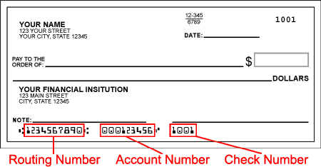

This authorization is to remain in full force and effective until we have received written notification from you of its termination in such time and in such manner as to afford the Financial Institution and us a reasonable opportunity to act on it. We deem this to be seven (7) days.

Name(s): ____________________________________________________________

Signature: ___________________________________________________________

Signature: ___________________________________________________________

Day Phone: ( ) _________________ Evening Phone: ( ) _________________

Note: All written credit/debit authorization must provide that the receiver may revoke the authorization only by notifying the originator in the manner specified in the authorization.

Important: Strategic MRCHT will appear on your bank statement.

Please fill out this form, attach a voided check and fax or mail it to us.
Strategic Merchant Solutions
3835R East Thousand Oaks Blvd. DEPT 167
Westlake Village, CA 91362
Phone – 888-614-6888 – email – Matt@strategicmerchant.com

